Project plan and Third iteration report

Group 6:
- Ragunandan Rao Malangully – 45
- Sandeep Siddhi – 57
- Raviteja Reddy Kandakatla – 33
- Pradeep Chaitanya Tirumalsetty - 61

Submitted on 11/11/2015

Introduction:

This document intends to provide an overall description of the project named “Travel Guide” in detail. The project schedule and the plan of action is also discussed. The proposal document submitted would give an insight about what the project is about. The main outcome of the second increment is the three modules of the application (weather, places of interest and language convertor modules). As of current state we have not deviated from our initial proposal that we submitted earlier.

Project goal and objectives:
Overall goal
The project goal is to put together a set of related and useful web services under one umbrella. The app intends to serve the needs of a person who is in search for some trivial information about a place that he in planning or intends to travel to. The significance of the application lies in the fact that it serves as a one stop shop to interact with various information sources. Additionally the app lets users to interact with social media. The objectives of the application are as follows.
Objectives
- To reduce the user time in searching for information across various sources.
- To develop a system architecture that can integrate the different features that the system proposes.
- To ensure that each iteration is tested thoroughly before heading to the next one.
- To develop a user friendly application.
- To provide user a tool to keep track of items that are required for the travel and the duration of the stay.
- Ensure that the user never misses important information in a touring country by providing the translate feature that translates the text into the user specified language.
- The user would never miss out on famous tourist locations as our app has a feature to suggest famous tourist attractions or hangout spots in a place.
- A tourist never feels away from home. The accommodation finder is a tool that helps the user in selecting his home away from home.
- Currency conversion is one of the major problems that tourists face when visiting other countries. The users of this app have no such worries as we take of currency conversions based on the latest foreign exchange rates.
- The user can prepare for the weather of the place he is visiting. The system predicts the latest weather information of the place of interest.

Import Existing Services/API
Primary services and their features
- Fixer API .This service provided over the URL “http://api.fixer.io/latest”. The API was utilized to provide the currency conversion. The user is provided with the flexibility of choosing the source and the destination conversion. This API does the conversion based on real time updated currency rates.
- The translation of the text provided to a language of user choice is offered by the yandex.com. The URL for the REST service interaction is “https://tech.yandex.com/translate/”. The input from the user would be the source language text and the option for conversion.
- The feature of creating, tracking and deleting items and tasks to be done is being built by the system using the mongoDB database hosted on mongo lab hosting service. This service would be designed within the system. This service implementation deviates from the normal process web service consumption. Instead we would develop a web service that stores, retrieves and manipulates data to and from a database. We have implemented this feature using the API calls and we are in the process of writing business logic in Java i.e Rest Services so that time lag faced during the API calls would be reduced using the REST services .
- The weather prediction is based on the data being returned from the web service provided by “Openweathermap.org” in the form an API. The URL for this REST service is “http://openweathermap.org/”. The task mostly concentrates on the UI display of the information being retrieved. The service consumes the data of place for which the weather is predicted. The output of the service would be a UI displaying the weather information generated by the service. We have implemented this feature successfully and tested the functionality and the test cases have been successfully passed.
- For the feature of accommodation suggestions, this feature is implemented alongside the places of interest feature. This feature provides a list of suggestions to stay for a particular location.

Detail Design of Services (using tools):
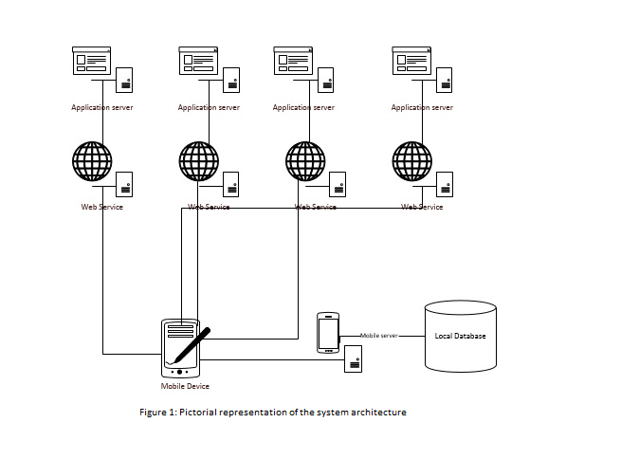

Third Increment Report
This document is a report of third iteration of work performed on the Travel Guide Mobile App. The document emphasizes on the details of the app and the progress of the work done so far in developing the app. This document intends to provide an overall description of the project named “Travel Guide” in detail.
The outcome of the third increment is places of Interest, accommodation and the integration of backend services and deployment of the application on Bluemix. Till this phase there has been negligible deviation from the initial project plan that was proposed.
In this phase of the project we have used the mentioned APIs to integrate the feature of finding places of interest based on the location. The module of currency conversion which was in development in the last phase has been integrated into the application. Thirdly we had to develop the module where in the user would get accommodation options in a place of his interest. This module has the feature of auto complete input box which would suggest places based on the user input. The modules of accommodation and places of interest would make use of the Google maps to display the places on the map. The final task was to create backend services for the application interaction with the Mongo DB using java servlets and then these services were deployed to IBM Bluemix for leveraging the benefits of it.

Class diagram for the high level design of the system
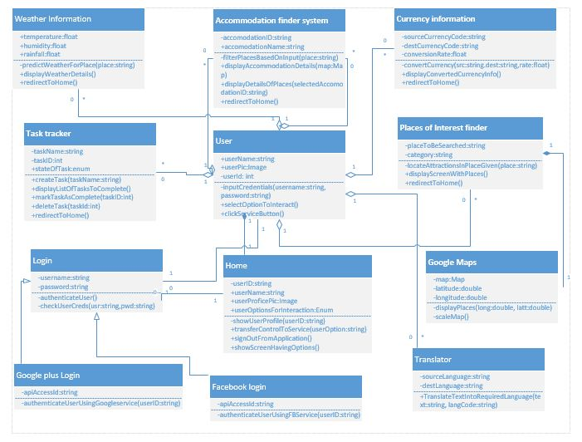
Figure 1
Figure 1 provides a bird eye view of the detailed design of the system where in the interaction of the various modules present in the system interact through the home controller to provide the services to the user. The home module plays the key role in the entire system and does the job of providing a one step interface for the user to interact with the various modules in the system.
Sequence diagram for each of the web service interaction
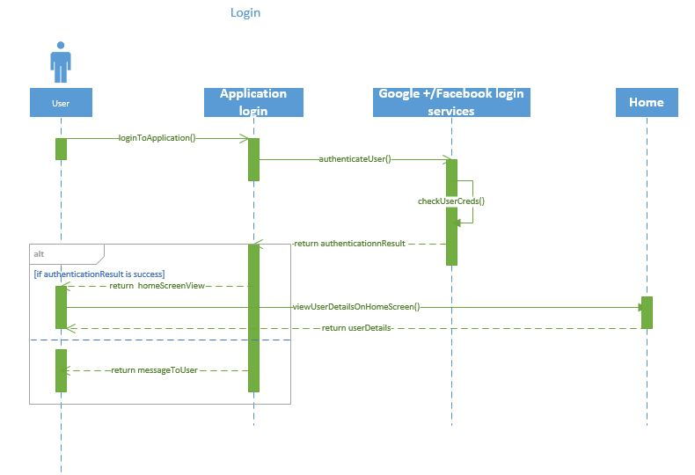
Figure 2
Figure 2 demonstrates a sequence diagram about how a user can Login to the App by using different Sign In options like Facebook, Google+. User has to provide credentials to the social media login page. In case of the Facebook login the user’s phone if has Facebook then there is no need to provide the credentials for the app. The case for google plus is normal wherein the user is required to provide credentials.
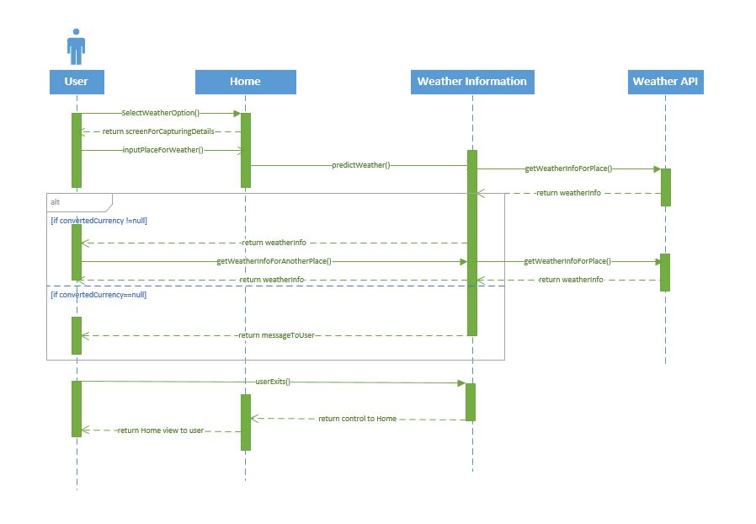
Figure 3
Figure 3 demonstrates a Sequence diagram about how a user can get the Weather of a particular location of user’s choice. Once user selects a place, app communicates with API and displays the temperature and weather information on the screen

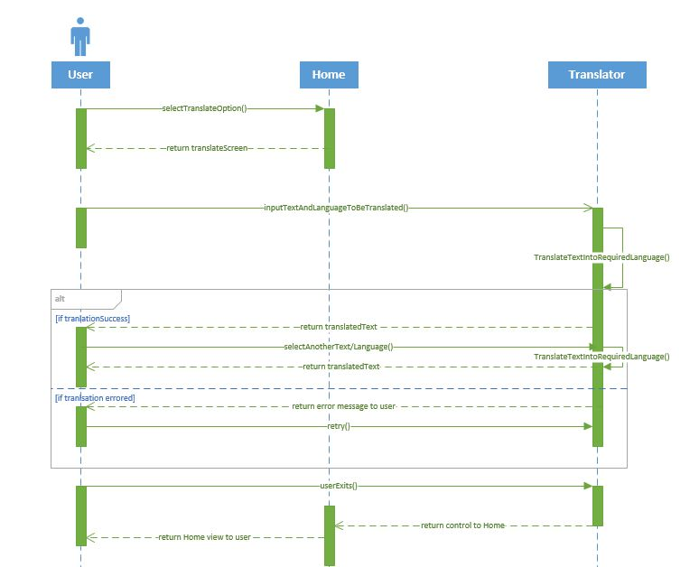
Figure 4
Figure 4 demonstrates a sequence diagram about how a user can use this App to translate the text from a Language to a Language of user’s choice. App uses API from frengly.com for language conversion. The choice of the source and the destination language can be a user choice. User has to enter text in one language and select the language that he wants to be converted.

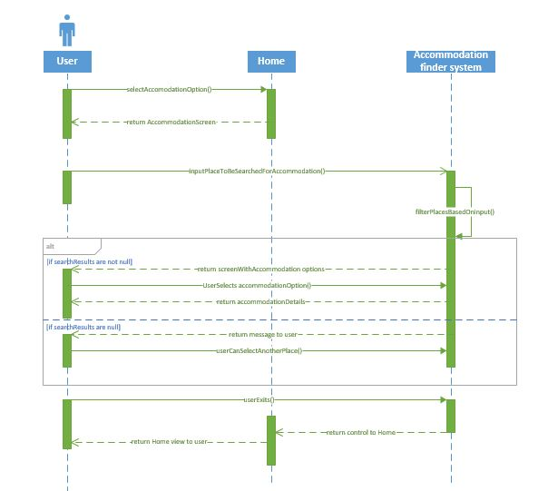
Figure 5
Figure 5 demonstrates a sequence diagram about how a user can get the Accommodation details of a particular location of user’s choice. This feature makes use of the google maps service to improve the results provided by the location basis. Each of the place is indicated in the map.

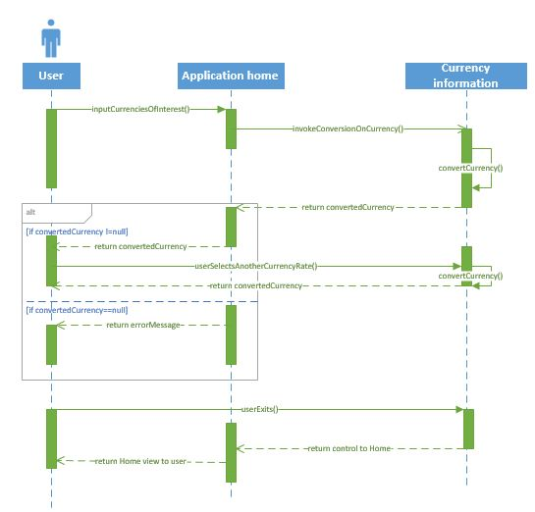
Figure 6
Figure 6 demonstrates a sequence diagram about how a user can get the varying currency rates of the Specified countries on that particular day. The currency exchange rates are updated per transaction basis. The user selects a particular currency and enters the value. The converted rate is displayed to the user.

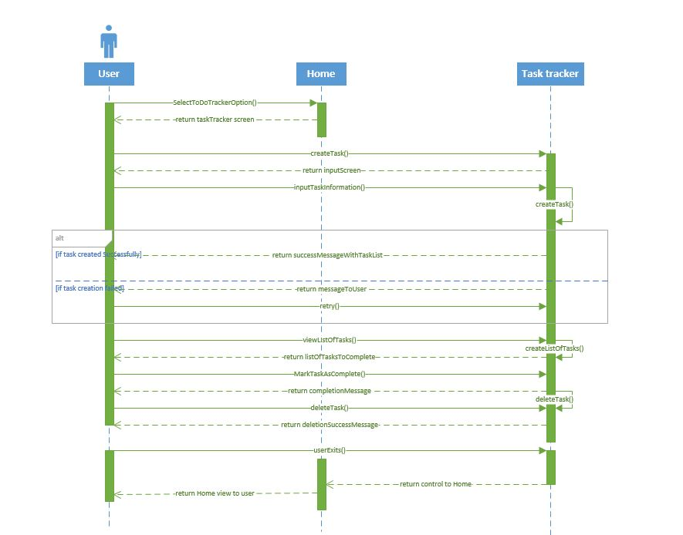

Figure 7
Figure 7 demonstrates a sequence diagram about how a user can create task. There is a feature to update the task title and the description of the task. Each task requires title and a description from the user. Each task can be scheduled for a notification so that a reminder can be provided to a user.

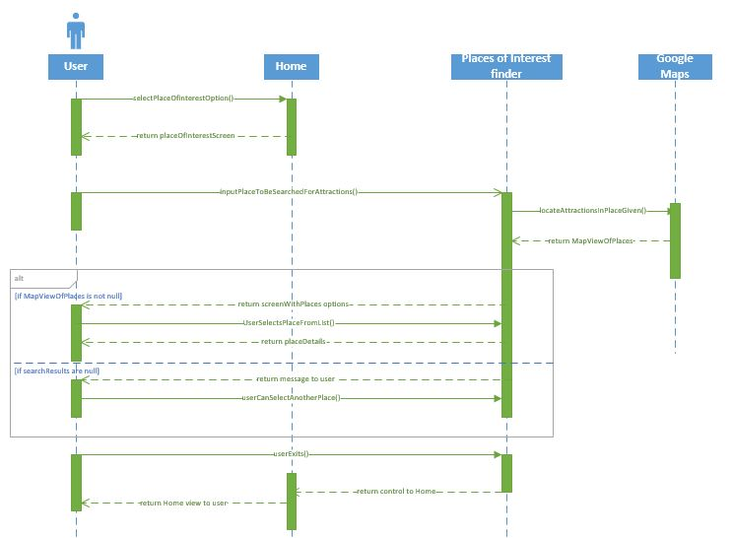

Figure 8
Figure 8 demonstrates a sequence diagram about how a user can get the places around a particular location of user’s choice.

State diagram of the system
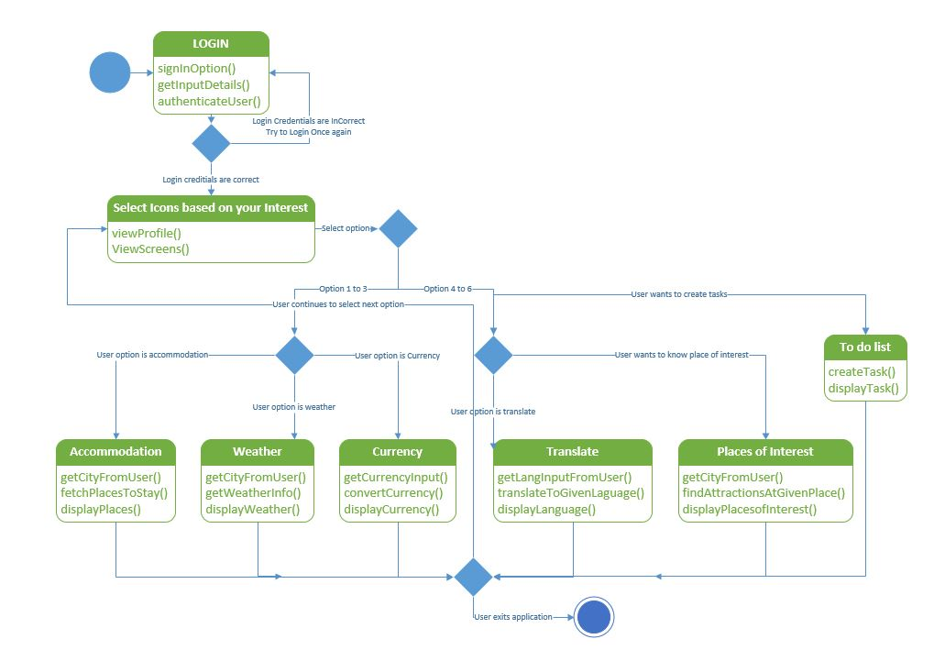
Figure 9
Figure 9 demonstrates a state diagram which explains High Level Design Architecture of the System. The initial step of the system is to login to the system. If the user has a social networking account like google plus or facebook he can login to the system. Else he could register himself with the app by providing some basic details. After successful login to the system the user views the home page where he can choose the feature he wants to interact with. Here the user has six options to choose from. Based on what he chooses the users follows the steps to interact with the corresponding feature. After successful interaction with a particular feature the user can end his session and close application. On the other hand he could visit the home page and begin interaction with another service.

Wireframes for the application
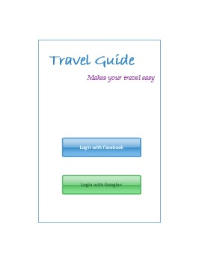
Figure 10
Figure 10 represents the startup screen for the travel guide APP. A user can use either Facebook or Google+ credentials to login into the app. The app accesses only display picture and basic details from the social networking application for its use and it will be confidential.

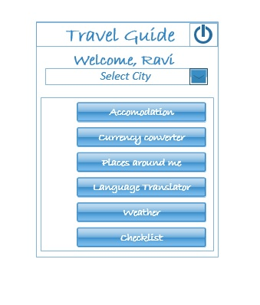
Figure 11 represents a wireframe for Homepage. All the features can be accessible from the home page. Every button represents a feature. User will be taken to the feature specific page.
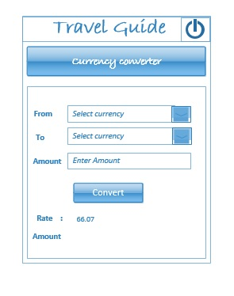
Figure 12
Figure 12 represents the Currency Converter Screen. User can use this feature to know the current value of a particular currency.
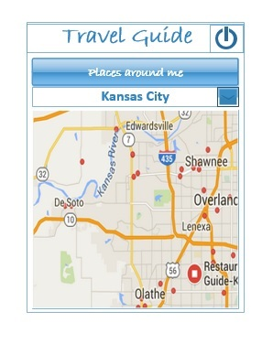
Figure 13
Figure 13 represents the Wireframe for Places of Interest. User can find the list of places in and around a place.Restaurants, movies, muesuems are some of the items that will be marked on the map.
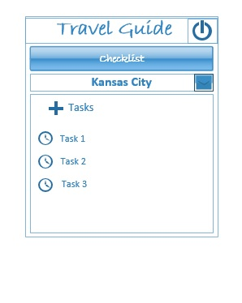
Figure 14
Figure 14 represents the wireFrame of CheckList Screen. This feature works as a reminder to the user about the taks he has to do.
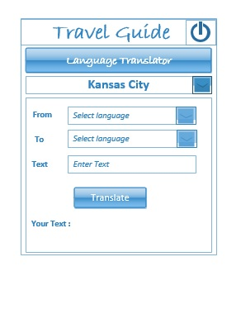
Figure 15
Figure 15 represents the WireFrame for Language Translator Screen.This feature helps user to learn foreign language for basic communication. Language translator support is given for a set of languages.

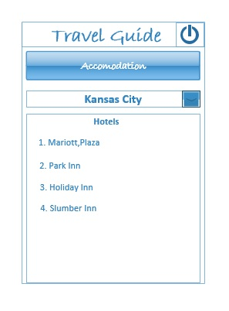
Figure 16
Figure 16 represents the WireFrame of Accomodation Finder Screen.
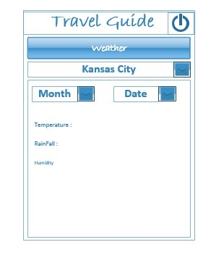
Figure 17
Figure 17 represents the WireFrame of Weather Screen.This feature gives weather information for a place for period of 7 days.

Mockups for the application
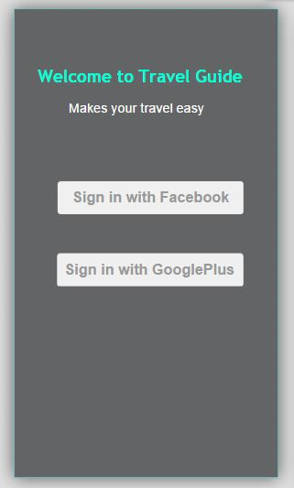
Figure 18
Figure 18 represents the Mockup for Login Screen.This figure depicts the login screen of travel guide.

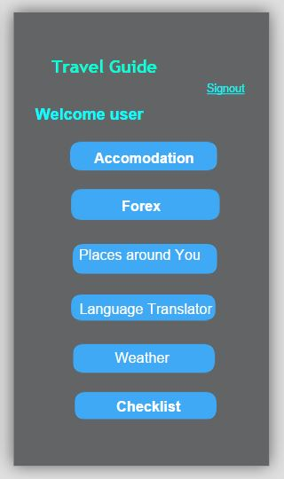
Figure 19
Figure 19 represents the Mockup for Homepage Screen.

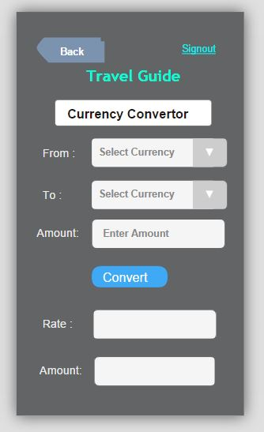
Figure 20
Figure 20 Represents the Mockup for Currency Converter Screen.
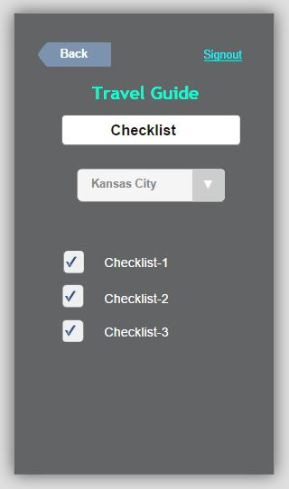
Figure 21
Figure 21 represents the Mockup for Checklist Screen.
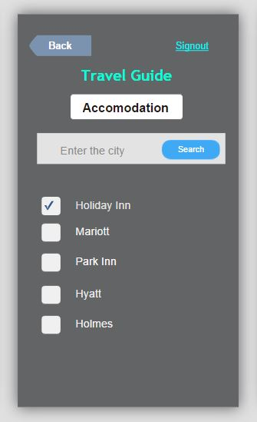
Figure 22
Figure 22 represents the Mockup for Accommodation Finder Screen.
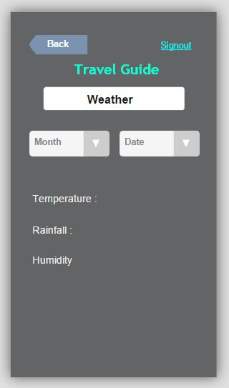
Figure 23
Figure 23 represents the Mockup for Weather Screen
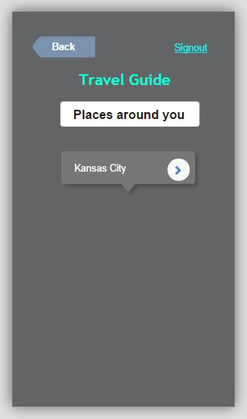
Figure 24
Figure 24 represents the Mockup for Places of Interest Screen.
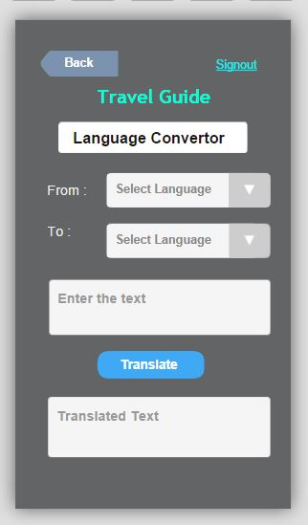
Figure 25
Figure 25 represents the Mockup for Language Translator Screen.

User Stories for this increment:
- Weather of place of interest is provided to the user based on his input.
- User tasks are stored into the database.
- The stored tasks of a user are retrieved from the database when the user logs in.
- Notifications can be set as a reminder for a task of users’ choice.
- User is provided with auto complete feature when he inputs some place of interest.
- There is a module where the user can convert one currency to another currency.
- Places of interest is suggested on maps when user inputs a place of choice.
- User is suggested places where he can stay when he travels to place of choice.
- The user cannot access the login page while he is in the home page.
- The user has the flexibility to login with wither Facebook or Google plus.
Design Patterns:
We have implemented the below design patterns in our project.
- Factory Pattern
- Singleton Pattern
The backend services of login and registration has been implemented using the factory pattern while creating an instance.One instance of factory will be created and this is implemented in Task creation feature using singleton pattern.
Testing:
This increment invloved integration of all the individually services devloped in the second phase. The individual APIs were already tested in using unit testing where in sample inputs were supplied to the APIs and output was verified for validation.
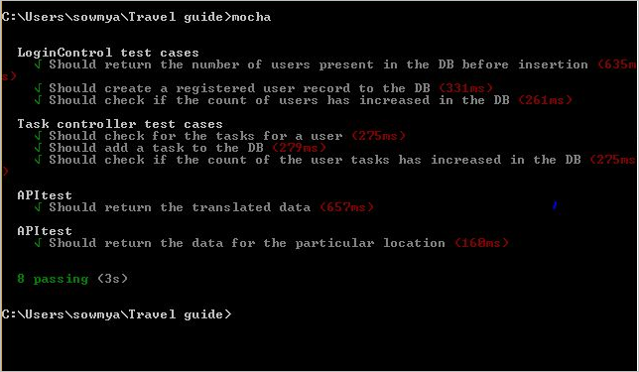
Figure 38 : Unit Test cases

Test Case for testing the Weather module:
- To verify the weather of places randomly.
- To test if the weather displayed for the entire week in correct.
Test cases for places of interest module:
- Verify if the places of interest are being returned for a place of choice.
- Enable the auto text feature when the user begins input of city.
- To verify if the maps display markers for the places suggested.
- Performance Testing
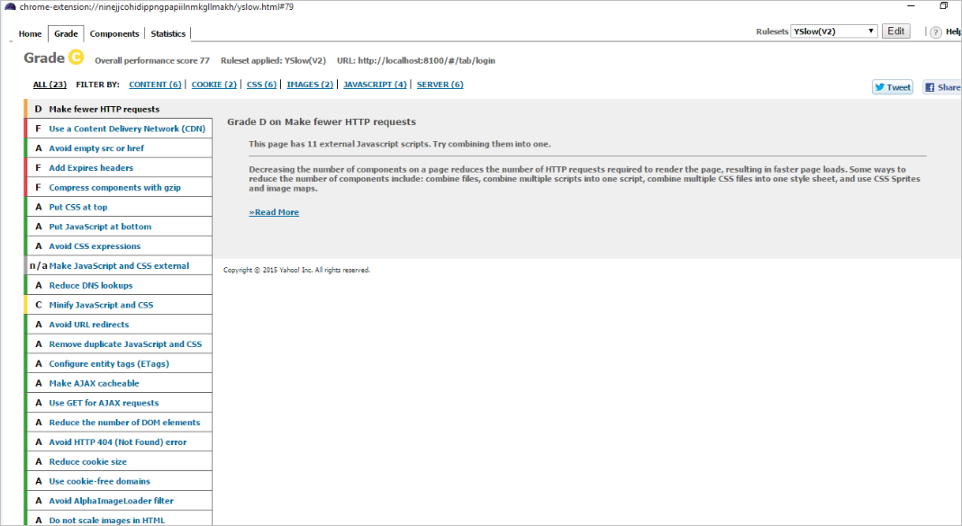

Implementation (using Ionic framework/Angular.js/Bootstrap/MongoDB/Bluemix):
We have implemented the Ionic framework in our project for building the front end UI and basic outlook of the pages. The ionic tabs concept has been used in our project for moving between the tabs of the app.The controller logic is implemented using Angular JS and it acts as an interface between the front end and backend. Bootstrap is used in the front end for better view of the app.For all the backend storage we have used MongoDB. Whenever the user has been registered in the app the details gets stored in the mongodb.All the user details gets stored in MongoDB. The task feature which is implemented in our project saves the task details like creation,updation and deletion in the mongodb.Our app has been deployed in the Bluemix for cloud accessibility and it is available using the below link. The rest services have been developed using Java servlet and these services act as a middle ware for the UI and the Mongo database. All the interactions that are performed in between the UI and the database are done through the middleware rest services.
Bluemix URLs:
http://travelguideservices.mybluemix.net/userServices
http://travelguideservices.mybluemix.net/userTaskService
Project Management Site Link:
We have used the Visual Studio Online as our Project Management tool and it can be accessed using the below link.
https://aseprojectgroup6.visualstudio.com/DefaultCollection/TravelGuide/dashboards

Screenshots of the Application UI for the third increment:

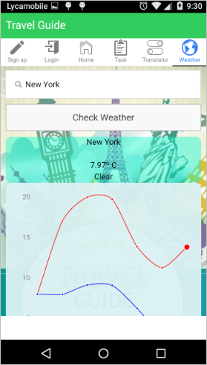
Figure 31 : Weather Screen
The weather feature will provide the Weather Forecast for a week starting from today for any place in graphical Notation. The minimum and the maxiumum temperature for that day is provided. The graph provided the range of the maximum and the minimum temperatures for the a range of one week for the place of interest.
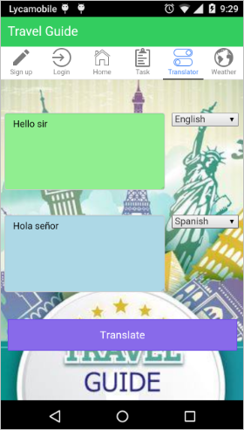
Figure 32: Language Translator Screen
The Language Translator provides the user a feature to translate Phrases into a foreign Language. The user has to enter the text in the language he knows. Then he can select the language for translation. The translated text is displayed in the text are below.
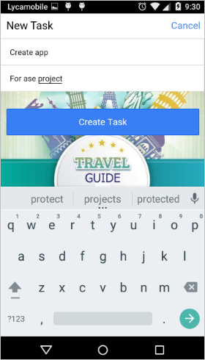
Figure 33: Create Task Screen
The Task module helps users to create a checklist of tasks and set notiifications so that a reminder will be created. The user can udpate the task in case he has any changes to be tracked. The user can set reminder for his task so that he can get a notification when he wants for that task.

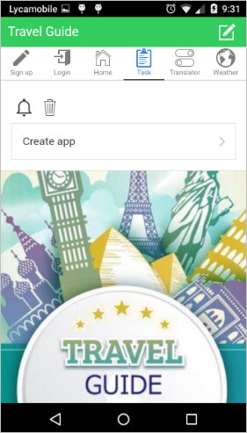
Figure 34 : Tasks List
The above screen consists of the list of tasks created by the user.”Create app” is a task in the tasks list.
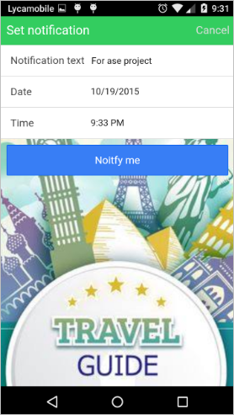

Figure 35: Setting Notifications
To generate reminders for a certain Task, a notification needs to set providing the date and time.
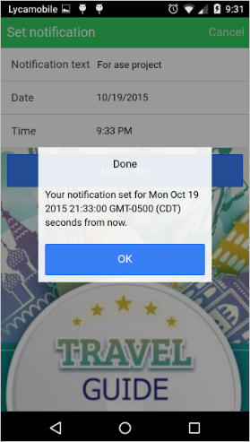
Figure 36 : Setting Notification
The above screen shows the Notification set for a “Ase Project” Task.
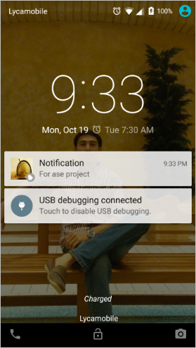
Figure 37: Notification Alert
The above screen shows the notification alert for a “Ase Project” Task

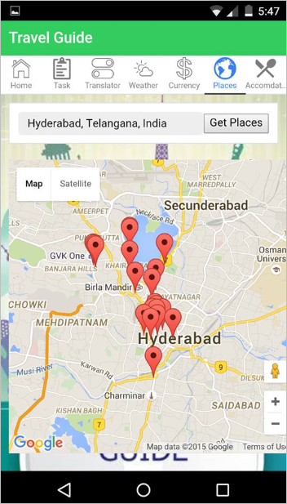
Fig 38: Places of interest image
The above image shows the map for the a location and the map marks the locations of the nearby places.
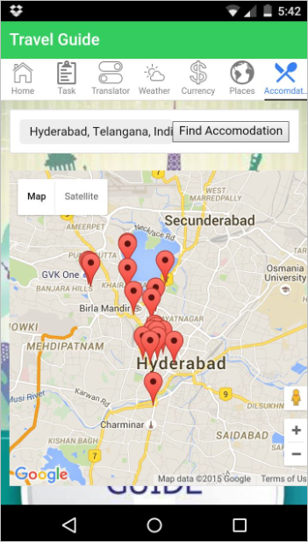
Fig 39: Accommodation feature image
The above image shows the map for a particular location and marks the nearby accomodation locations for a particular place.
Bibliography

[1], [2], [3] and [4] – Content referred from the article “The world’s 50 best travel apps” by the Time out group. URL: http://www.timeout.com/travel/features/1169/the-worlds-50-best-travel-apps
References:
“Packing list” by Travellerspoint Foundation. URL: http://www.travellerspoint.com/packing-list.cfm
Project Management URL: https://www.visualstudio.com/en-us/products/what-is-visual-studio-online-vs.aspx
The guide for Google plus login URL: https://developers.google.com/+/web/signin/
Facebook sign in option guided by URL: https://developers.facebook.com/docs/facebook-login

